Y2Q1W5

Solomon's Wisdom
Ask: Have you ever wished that someone would tell you the right answers?
Powerpoint Quiz: Move to each side of the room to show what you think is the right answer.
Say: Sometimes it is hard to know when something is right. – Some of the slides were optical illusions – that means that they look different than they really are.

Bible Story

Sing some songs.

Say: Solomon had some really hard decisions to make didn't he?

Return to tables
Memory Verse: Fill in the blanks and then say the memory verse on the colouring page.
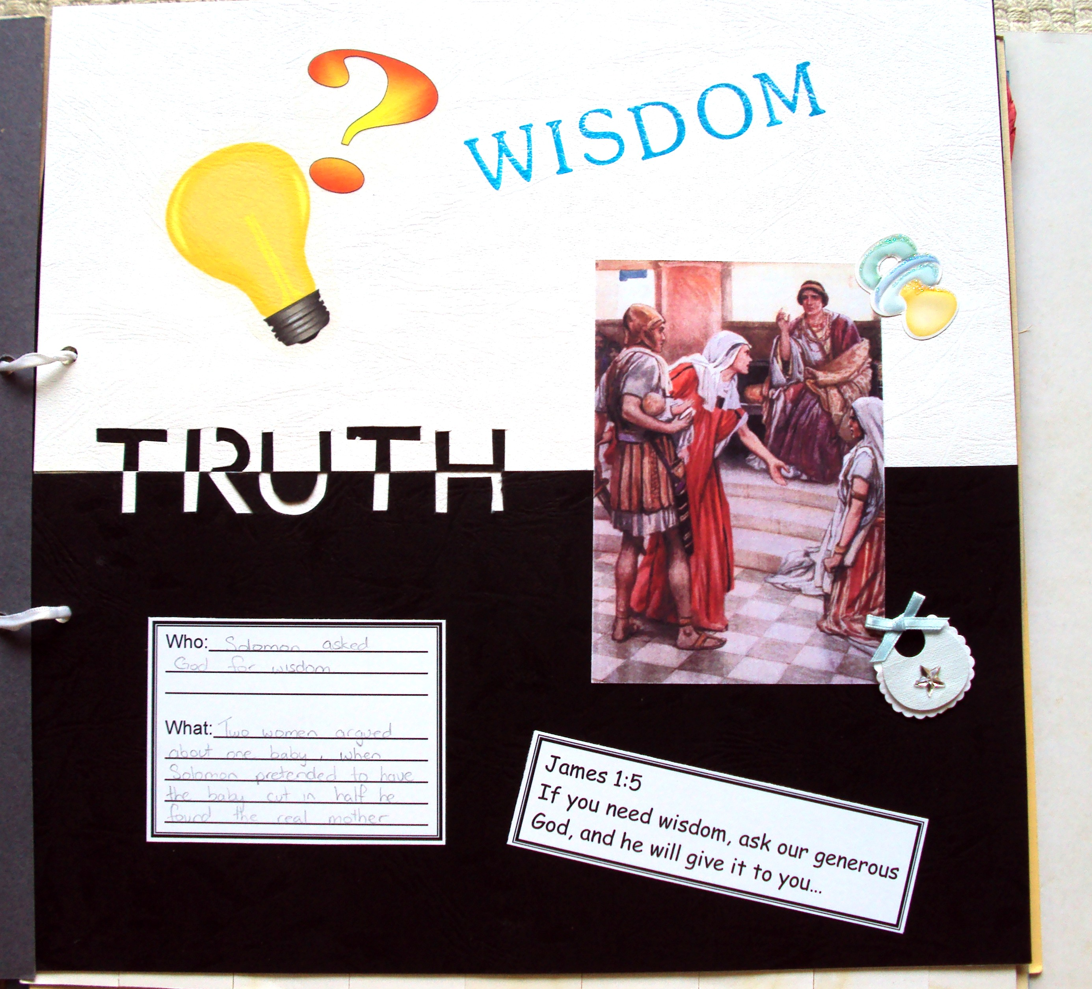
Say: Every week this term we will be making a page to add to a scrapbook.
Craft:
- Choose two pieces coloured cardboard. Cut them in half and join together.
- Use a stencil to write TRUTH.
- Stick on photo, light bulb & question mark, baby sticker, verse and who/what card.
- Use the stamp to stamp WISDOM

Discuss the following depending on age, interest and time:
What does wisdom mean?
What are some choices or decisions that you have to make?
What are some things that can help you make wise choices? (Good-Bad Lists, people to advise you etc)
Who can you ask for advice?
If there is time – draw a flowchart of steps that you can take to help you make important decisions.
Does someone who is wise know everything? (No – and they are wise enough to know it)
What does someone who is wise do when they don't know the answer?

Primary / Junior / Teen: This term, those of you who would like to get a Bible to take home, may take one of the orange Commandment pages and add to your book. Each week you come you can put a sticker on it and when it is all complete we will get you a Bible to take home and keep.

Ask: What are some hard decisions that we might have to make?
Ask: What can we do to become more wise?
Ask: Who can we ask when we don't know what to do?

Finish with prayer at each table.

